SOP – Mass Email Marketing Campaign (Cleaning Services Menu/Flyer)

Purpose
To inform existing and past clients about the full range of services offered by Master Sparkle's Cleaning Service and generate additional bookings through cross-selling and repeat business.

Campaign Details

Email Subject Line
Use one of the approved subject lines:
- ✨ Did You Know? We Offer More Than House Cleaning!
- Your One-Stop Solution for Professional Cleaning Services
- Need More Than a House Clean? We've Got You Covered!
- Exclusive Client Offer – Bundle Services & Save Time

Target Audience
Send to:
- Existing clients
- Previous clients
- Clients with completed bookings
- Clients who have received quotes
- Commercial clients
- Property managers and real estate contacts
Do not send to:
- Clients who have requested to unsubscribe
- Invalid email addresses
- Duplicate contacts

Email Content
Good Day,
Thank you for choosing Master Sparkle's Cleaning Service.
Many of our clients know us for our professional house cleaning services, but we also provide a comprehensive range of cleaning solutions for both residential and commercial properties.
Please find attached our Cleaning Services Guide, which outlines the full range of services we offer.
As one of our valued clients, you may also benefit from combining multiple services, helping you save time while enjoying priority scheduling for future bookings.
If you'd like a quote or have any questions, simply reply to this email or contact us using the details below. We'd be happy to assist.
Thank you for your continued support. We look forward to helping you with all your cleaning needs.
Kind Regards,
Master Sparkle's Cleaning Service
 0424 262 102
 0483 909 620
 mastersparklescleaning@gmail.com
One Company. Every Cleaning Solution.

Attachment
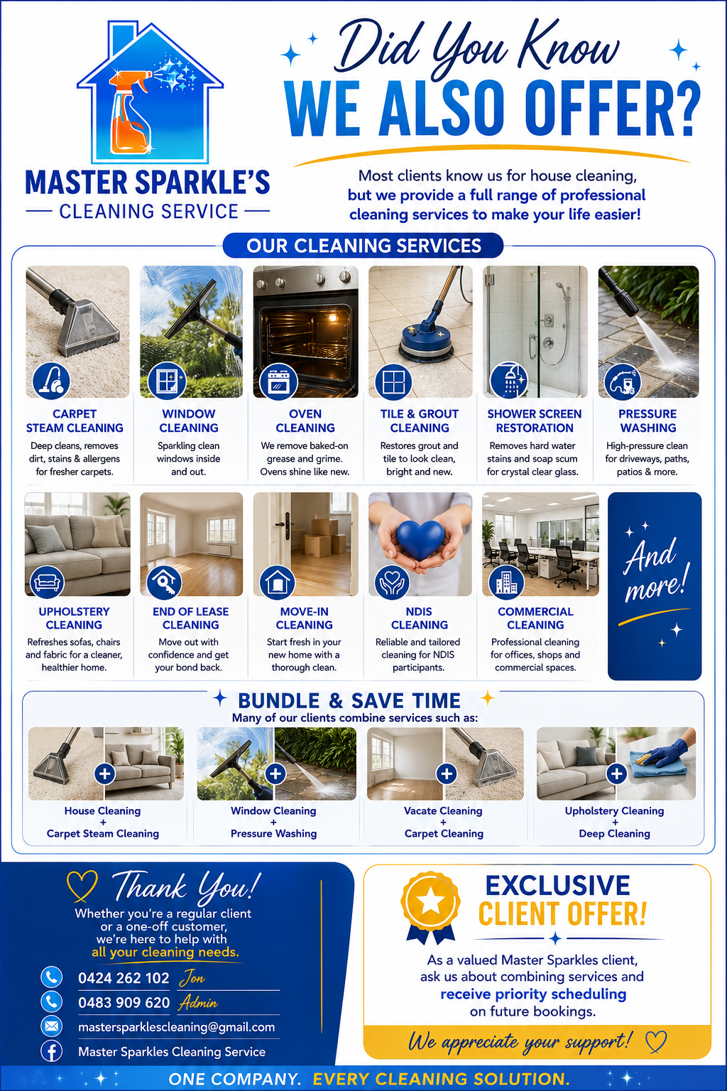
Verify:
☐ Correct flyer attached
☐ Flyer opens correctly
☐ Contact details are visible and accurate

Sending Procedure

Step 1: Create Email
- Insert approved subject line
- Paste approved email body
- Attach Cleaning Services Flyer

Step 2: Test Email
Send test email to:
- Admin email
- Personal work email
Check:
☐ Subject line displays correctly
☐ Flyer attachment opens
☐ Mobile formatting looks good
☐ Contact details are correct

Step 3: Send Campaign
- Use BCC or email marketing software
- Send during business hours
- Preferred times:
  - 9:00 AM – 11:00 AM
  - 1:00 PM – 3:00 PM

